Creating an Office 365 Development Environment
Lab Time: 45 minutes
Lab Folder: C: \Student\Modules\01_GettingStarted\Lab
Lab Overview: In this lab you will get up and running with an Office 365 and SharePoint Online development environment. You should be working with a Windows PC that has been set up according to the Setup.pdf document that accompanies this course. You will perform the necessary tasks of creating a new Office 365 trial account which will create an Azure Active Directory (AAD) tenant and a SharePoint Online environment that you will use to complete your lab exercise throughout his training course. Once you have created and tested your Office 365 tenant, you can optionally create a trial subscription for Microsoft Azure (unless you already have an Azure account that you can use). Along the way, you will use PowerShell libraries for SharePoint Online and Microsoft Azure to verify you can connect to your Office 365 and Azure accounts and automate developer tasks using PowerShell scripts.

Exercise 1: Download a Local Copy of the Student Lab Files
In this exercise, you will use the GIT utility to download a local copy of the student files from the MSTDEV repository in GitHub. Note that this exercise assumes that GIT has already been installed on your PC as discussed in the setup guide for this course.
- Launch a browser and navigate to the GitHub repository for this course at the following URL.
https://github.com/CriticalPathTraining/MSTDEV
- You should see the home page for the repository as shown in the following screenshot.
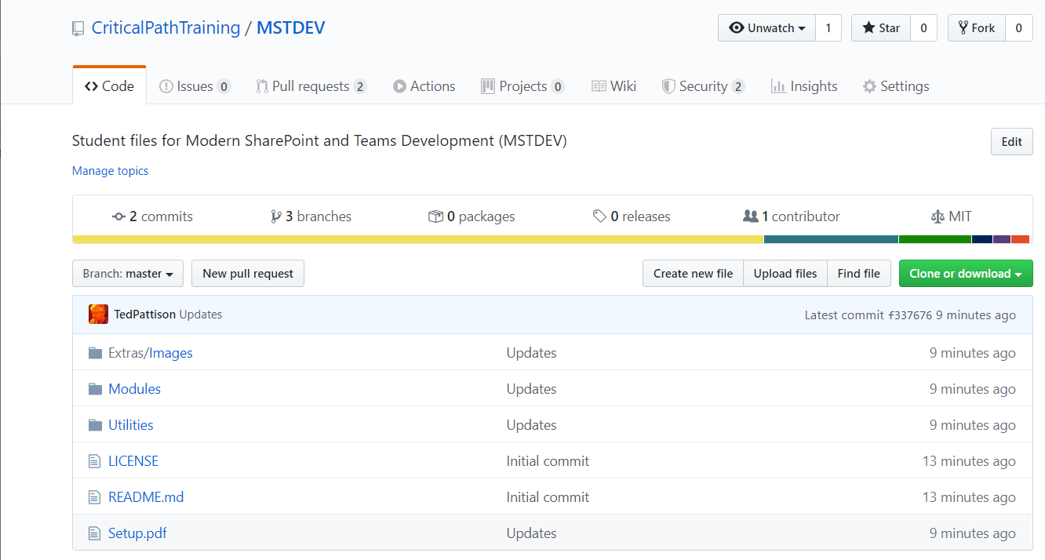
- Copy the URL to clone the repository.
  - On the home page of the MSTDEV repository, click the green Clone or download dropdown menu.
  - Click the Copy to clipboard button to copy the URL for cloning to the Widows clipboard.
- Use GIT to clone the MSTDEV repository.
  - Open up a Windows PowerShell command prompt.
  - Type in and execute the following git command to download the student files to a local folder named C:\Student. Note that you copied the URL to github.com in the previous step and you can paste it from the Windows clipboard instead of typing it.
git clone https://github.com/CriticalPathTraining/MSTDEV.git C:\Student
  - When the git clone command runs, it will create a local copy of the repository on your local machine in the C:\Student folder.
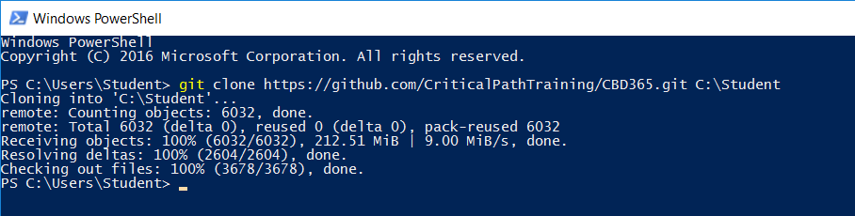
  - When the git clone command completes, open Windows Explorer and examine the Student folder. You should be able to see the Student folder has child folders named Extras, Modules and Scripts.
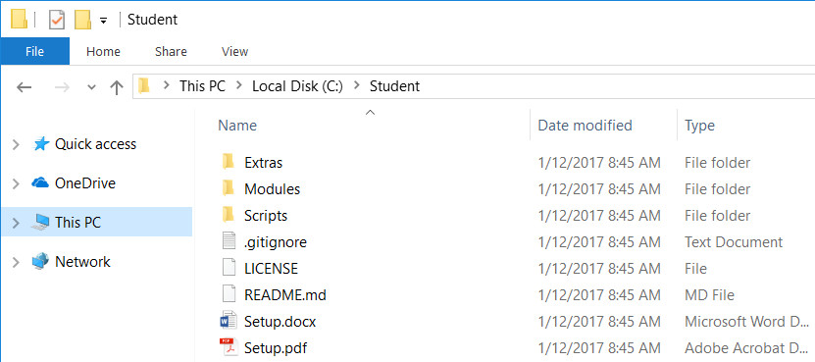
  - Drill into the Modules folder and look in the folder inside named 01_GettingStarted.
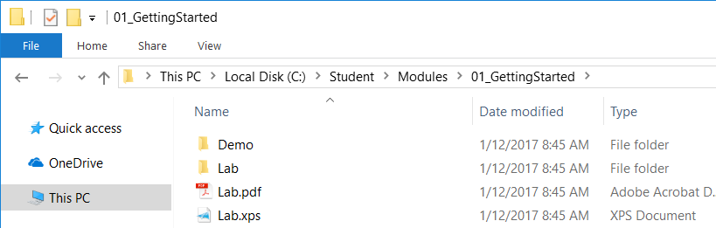
You can see that the 01_GettingStarted folder contains two child folders named Demo and Lab.

Exercise 2: Create an Office 365 Trial Account
In this exercise, you will create a new Office 365 trial account which in turn will create a new Office 365 tenant. This Office 365 tenant will allow you to create up to 25 user accounts with Enterprise E5 trial licenses. Note that the Enterprise E5 trial license provides the benefits of the Office 365, SharePoint Online and Power BI Pro. Being able to create multiple Office 365 user accounts in your cloud-based testing environment will be important so that you can test the effects working with multiple users.
- Navigate to the Office 365 trial sign up web page.
  - Launch the Chrome browser.
  - Copy and paste the following URL into the address bar of the incognito window to navigate to the signup page.
https://go.microsoft.com/fwlink/p/?LinkID=698279&culture=en-US&country=US
  - You should now see the form you need to fill out to create your new Office 365 E5 trial.
  - Enter your email address and click Next.
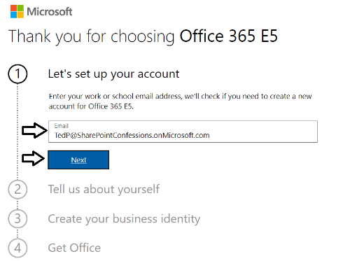
If you enter an email address for an organization account, the form provides the option to sign in. Do not click the Sign in button because you don't want to sign with an existing organization account. The purpose of this exercise is to create a new organizational account in a new Microsoft 365 tenant.
  - Click the Create a new account instead link.
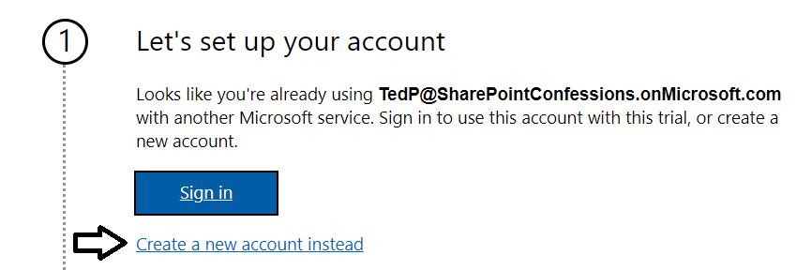
  - Enter your First name and Last name.
  - Enter your mobile phone number as the Business phone number.
  - Provides values for Company size and Country or region and click Next.
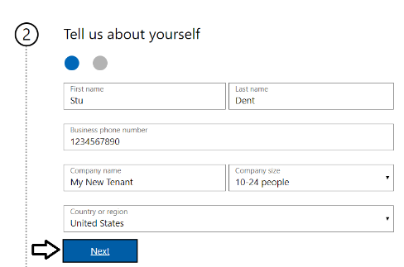
Whatever Company name you enter will be used as the name of the Azure AD tenant that will be created during the sign up process.
  - When prompted to prove you're not a robot, select the Text me option and ensure Phone number of for your mobile phone.
  - Click Send Verification Code.
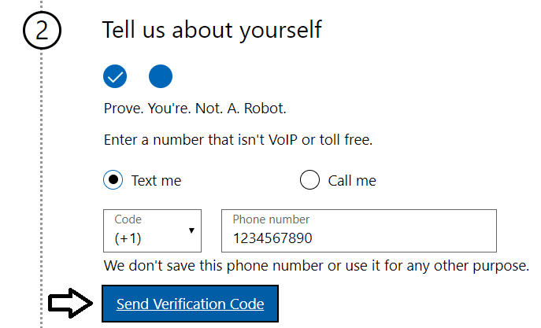
  - Retrieve the access code form your mobile device and use it to complete the validation process.
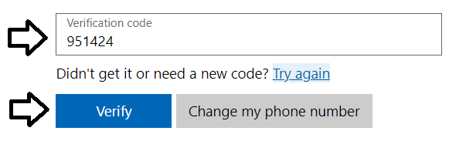
  - In the Create your business identity step, locate the textbox into which you will enter a domain name.
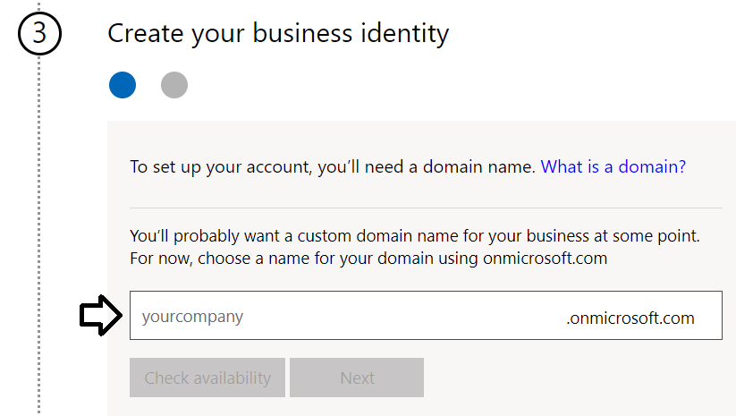
Note that the company name you enter in this textbox will be used to create an Internet domain name for a new Microsoft 365 tenant. For example, if you were to enter a company name of cptstudent, it would result in the creation of a new Office 365 tenant within a domain of cptstudent.onMicrosoft.com. The user name you enter will be used to create the first user account which will be given global admin permissions throughout the Azure AD tenant. If you enter a user name of Student, then the email address as well as user principal name for this account will be student@cptstudent.onMicrosoft.com
  - Enter a domain name for your new Microsoft 365 tenant.
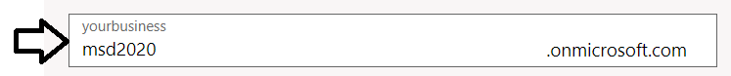
  - If the domain name you enter is not available, modify the domain name until you can verify that it is available.
  - Once you have created a domain name that is available, click Next.
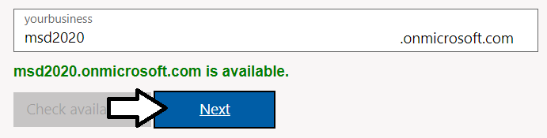
  - Enter a Name for your user account, a Password that you will remember and then click Sign up.
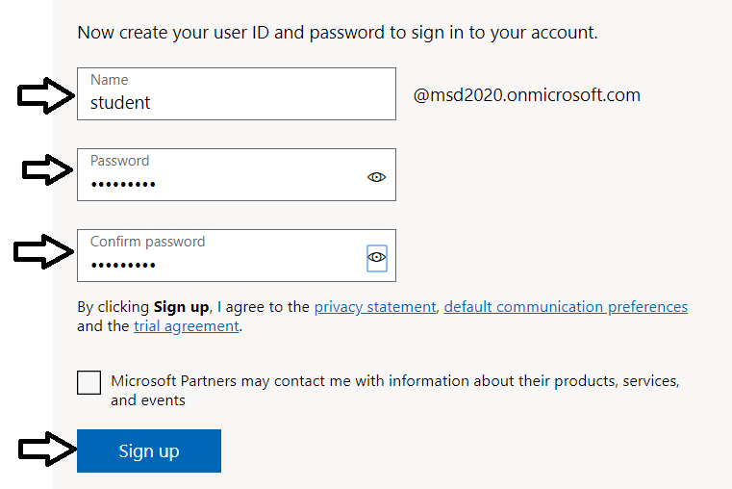
At this point, the Sign up process should begin to provision your new Microsoft 365 tenant and your new organizational account.
  - Once the provision process completes, take note of your new user ID and click the Go To Setup button.
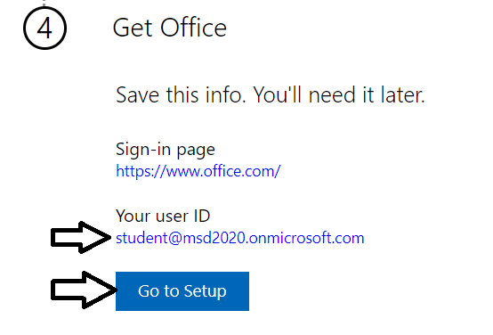
You have just created a new Microsoft 365 tenant with a 30-day trial for 25 Office 365 E5 licenses. Note that some Microsoft cloud services within your new tenant such as the Microsoft 365 admin center, Power BI, Power Apps and Flow can be accessed immediately. Other Office 365 services such as SharePoint Online, OneDrive for Business and your Outlook mailbox will not be ready immediately and can take some time to provision.
  - If you see the Personalize your sign-in and email setup page, click Exit and continue later.
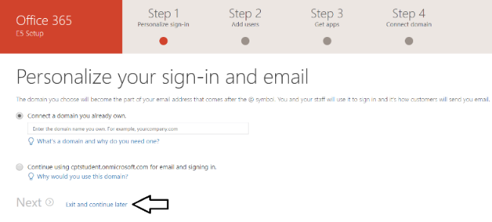
  - You should now be located at the home page of the Microsoft 365 admin center.
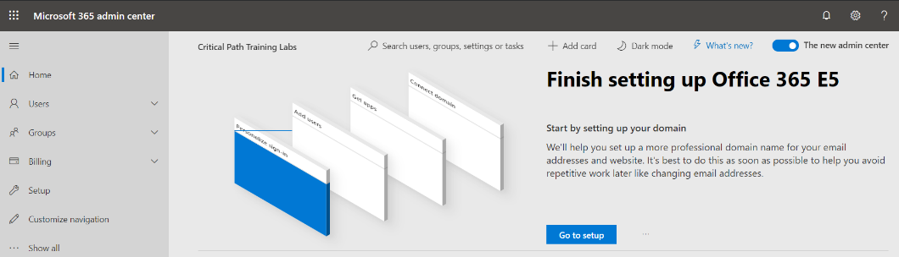
If you don’t see the home page of the Microsoft 365 admin center, navigate to https://admin.microsoft.com/Adminportal.
- Inspect the set of active users in the current Azure AD tenant.
  - Locate the top Collapse navigation menu with the hamburger icon just under the Microsoft 365 App Launcher menu.
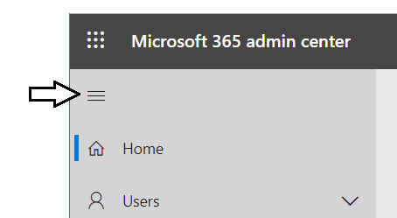
  - Toggle the Collapse navigation menu button to see how it collapses and expands the left navigation menu.
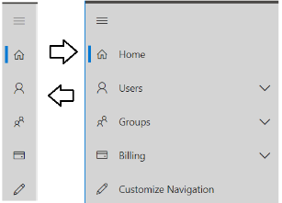
  - Navigate to the Active users view where you should be able to verify that the user account you are currently logged in as is the only user account that exists in the current tenant.
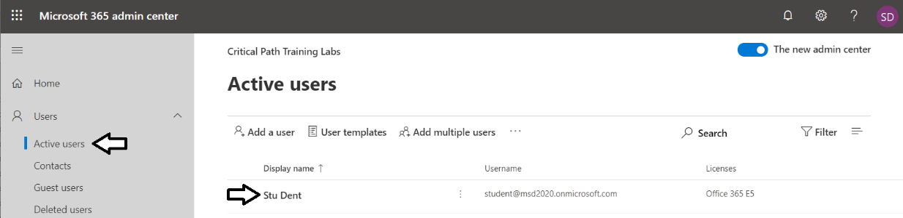
Remember that your account is global tenant administrator. You have permissions to configure any settings throughout the tenant.
- Create a second Azure AD user account in your new Azure AD tenant.
  - On the Active Users page, click the button Add a user button to create a new user account
. 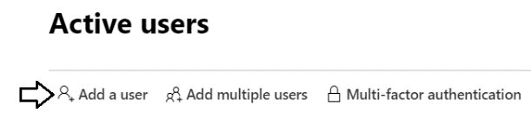
  - Fill in the Set up the basics form with information for a new user account. When creating this account, you can use any name you would like. These lab instructions will demonstrate this by creating a user account for a person named James Bond with a user name and email of JamesB@msd2020.onmicrosoft.com.
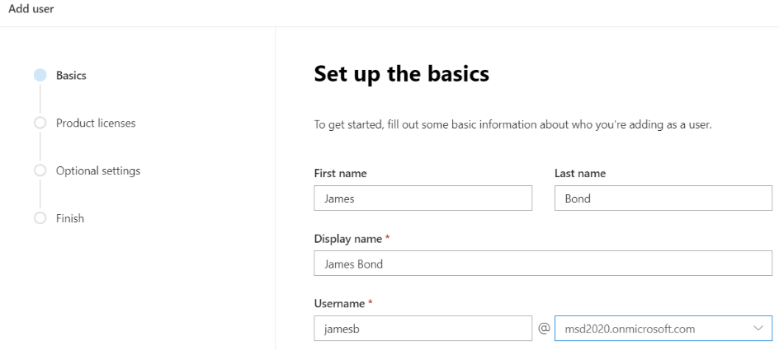
  - Move below to the Password settings section.
  - Select the option for Let me create the password.
  - Enter a password of pass@word1 into the textbox labeled Password.
  - Uncheck the checkbox for the Require this user change their password when they first sign in option.
  - Click Next.
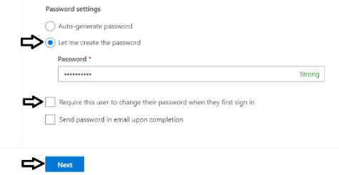
  - In the Product licenses section, make sure the Office 365 E5 license is set to On.
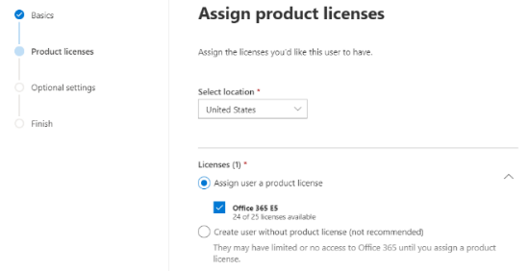
Note that the new account is usually assigned a trial license for Office 365 E5 plan. However, it’s a good practice to check and make sure the new user has been assigned a license for Office 365 E5.
  - Click the Next button down below.
  - On the Optional settings view, click Next.
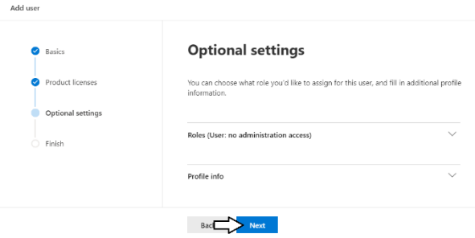
  - On the Finish view, Click the Finish adding button at the bottom to create the new user account.
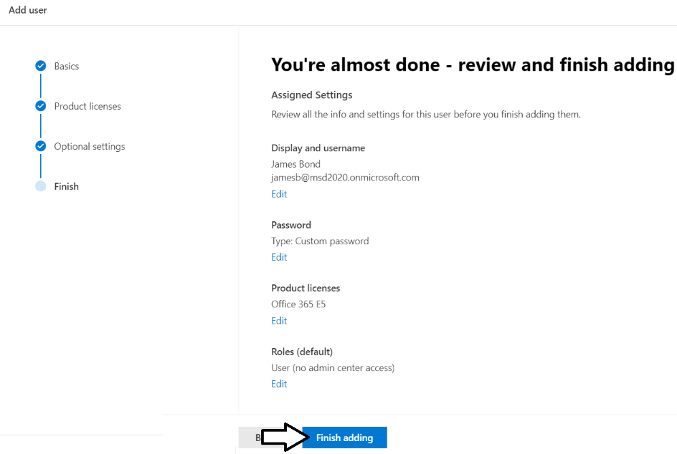
  - You should see the Finish view with a message indicating that the new user account has been created.
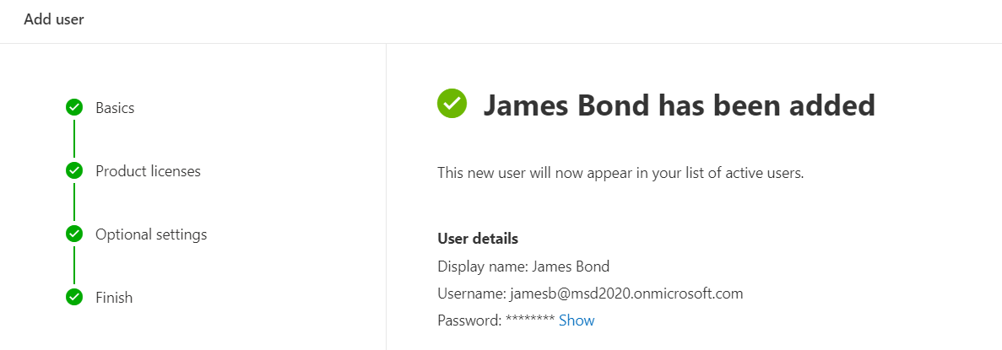
  - Click the Close button at the bottom of the Finish view to close the Add User pane on the right.
  - Verify that the new user account has been created and is displayed along with your primary Office 365 user account.
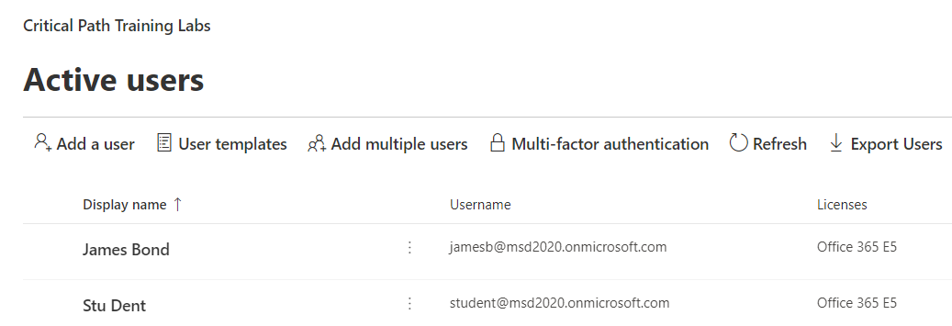
Now you know how to create a new Active Directory user account by hand. Next, you will accomplish the same goa using a PowerShell script o automate the task.

Exercise 3: Create New Office 365 User Accounts using a PowerShell Script
In this exercise, you will use the Azure AD PowerShell module to verify connectivity to your Office 365 tenant and to create a few new user accounts in your new Active Directory tenant.
- Open and review the PowerShell script named CreateUserAccountsFromCSV.ps1.
  - Using Windows Explorer, open the folder at the following location.
C:\Student\Modules\01_GettingStarted\Lab\CreateUsersScript
  - You should see several files including UserData.csv and CreateUserAccountsFromCSV.ps1.
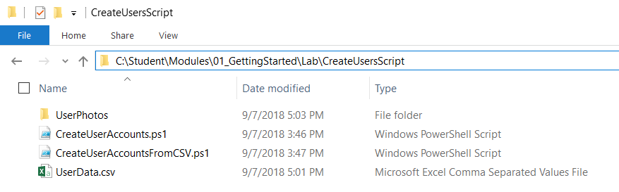
  - Open UserData.csv file in Notepad and examine the data inside which is formatted in a CSV format.
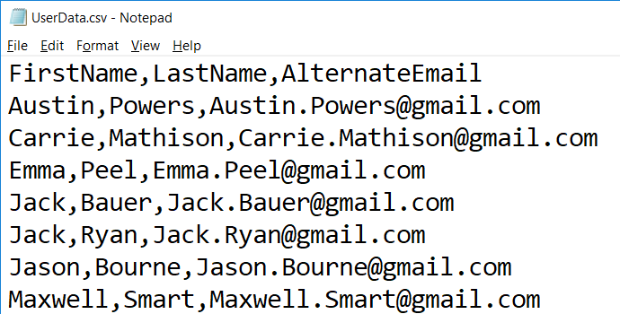
  - Close UserData.csv without saving any changes.
  - Right click on the file named CreateUserAccountsFromCSV.ps1 and click Edit to open the file in the PowerShell ISE.
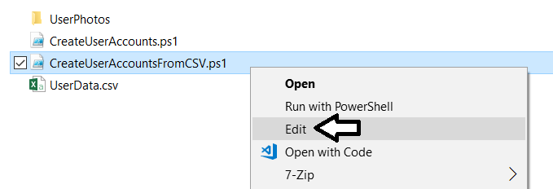
  - Take a moment to walk through the code in this PowerShell script.
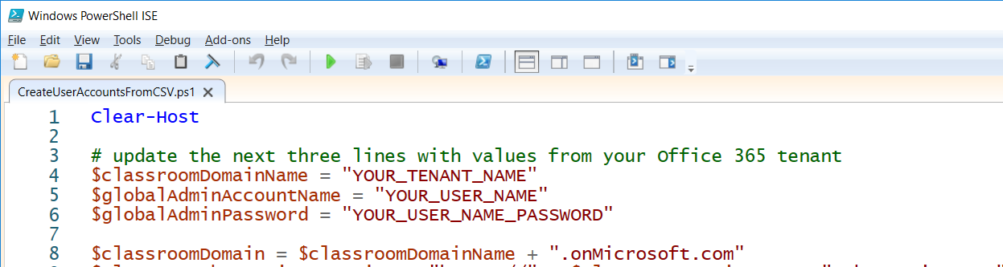
  - As you can see, the script creates new Azure AD user accounts using the New-AzureADUser cmdlet.
$password = "pass@word1"
$passwordProfile = New-Object -TypeName Microsoft.Open.AzureAD.Model.PasswordProfile
$passwordProfile.Password = $password
$passwordProfile.EnforceChangePasswordPolicy = $false
$passwordProfile.ForceChangePasswordNextLogin =$false

$secureStringPassword = ConvertTo-SecureString -String "pass@word1" -AsPlainText -Force

# Create new user account
$newUser = New-AzureADUser `
-DisplayName $displayName `
-GivenName $firstName `
-Surname $lastName `
-MailNickName $mailNickname `
-PasswordProfile $passwordProfile `
-PasswordPolicies "DisablePasswordExpiration, DisableStrongPassword" `
-UserPrincipalName $userPrincipalName `
-UsageLocation "US" `
-AccountEnabled $True
Note that any user account created with this script will have a password of pass@word1.
  - Move to the top of the script and edit the script to include the details for your tenant name, user account and password.
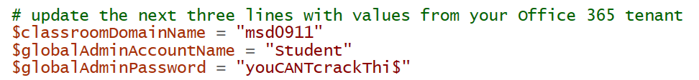
  - Save your changes to CreateUserAccountsFromCSV.ps1.
In the next step you will execute the PowerShell script which means you must have the ability to run PowerShell scripts on your Windows PC. If you are not able to run PowerShell scripts, you might need to open a PowerShell prompt as Administrator and then execute the Set-ExecutionPolicy Bypass command.
- Run the PowerShell script named CreateUserAccountsFromCSV.ps1 to create new user accounts in your new AD tenant.
  - Inside the Windows PowerShell ISE, click the green arrow button on the toolbar to execute the script.
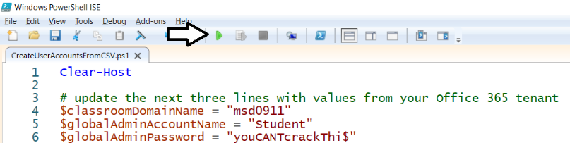
  - Once the script executes, return to the Active users view in Microsoft 365 admin center to verify new users have been created.
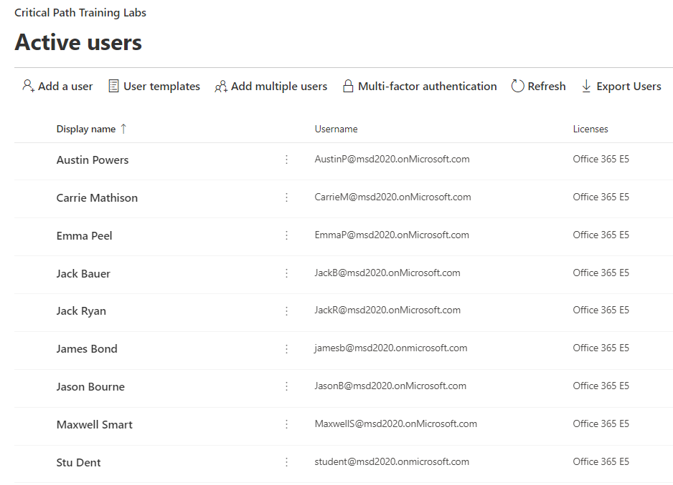
Note, there are user photos in the folder at C:\Student\Modules\01_GettingStarted\Lab\CreateUsersScript\UserPhotos if you want to upload photos for each of these users. Uploading user photos is not required so we leave this as an optional exercise for the reader.

Exercise 4: Navigate to the Root SharePoint Site for Your Tenant
In this exercise, you will navigate to the root SharePoint site for your new Office 365 tenant. You will not do much with this site in this lab. However, you will be using this SharePoint site in later labs as you develop SharePoint Framework webparts.
NOTE: When you create an Office 365 trial tenant, it takes a certain amount of time to provision the standard SharePoint sites that are automatically created. In many cases, the SharePoint sites will be ready within 5 minutes. However, it is not uncommon for the provisioning to take as long as 10-20 minutes. In less common scenarios, it might take over an hour for the sites to be created. If the SharePoint sites in your tenant are still being provisioned, you must wait for them to be ready before you can work on this exercise.
- Navigate to your root SharePoint site in your new Office 365 tenant.
  - Take the following URL and replace YOUR_TENANT_NAME with the name of your new Office 365 tenant.
https://YOUR_TENANT_NAME.sharepoint.com
  - Paste the URL into the address bar of the browser to navigate to your root SharePoint site.
  - When prompted, log in with your new Office 365 user account credentials.
  - At this point, you should see the home page of the Communications site which is the root SharePoint site for your tenant.
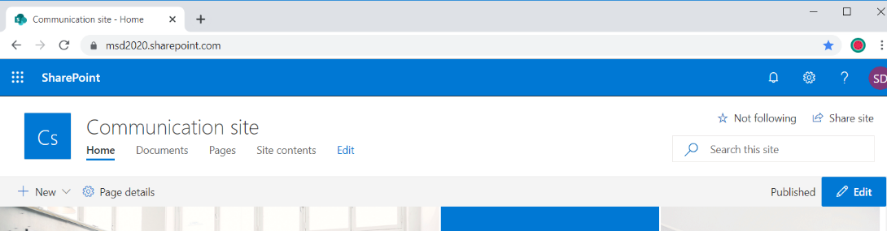
  - Click the Site contents link to see the Site contents page.
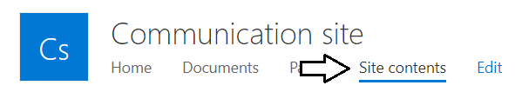
  - Inspect the contents of the Communications site.
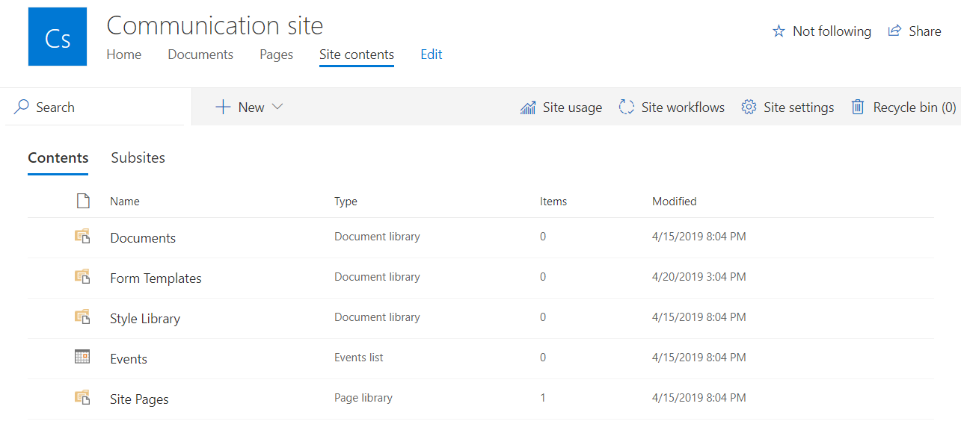
Take a moment to navigate around in this SharePoint Communications site. You will find that this is a standard site that includes the standard lists and document libraries included with every new Communications site. You might consider adding a bookmark to this site because you will be returning when you begin the labs which work with the SharePoint Framework.

Exercise 5: Create a New SharePoint Site using the SharePoint Admin Center
In this exercise, you will navigate to the SharePoint admin center where it is possible to administer the SharePoint sites within the current Office 365 tenant. You will also go through the process of manually creating a new SharePoint team site.
- Navigate to the SharePoint admin center for your new Office 365 tenant.
  - Take the following URL and replace YOUR_TENANT_NAME with the name of your new Office 365 tenant.
https://YOUR_TENANT_NAME-admin.sharepoint.com
  - Paste the URL into the browser to navigate to the SharePoint site collection which is the SharePoint admin center.
  - At this point, you should see the site collection page of the SharePoint admin center.
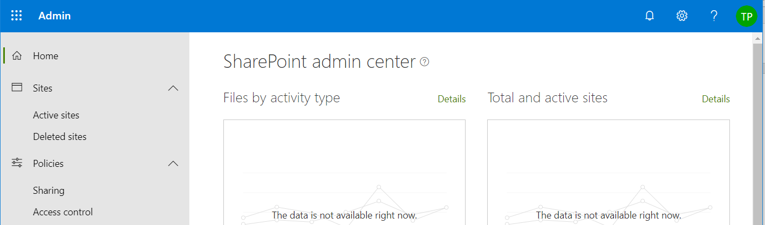
- Create a new SharePoint team site by hand using the SharePoint admin center.
  - Click the Active sites link in the left navigation.
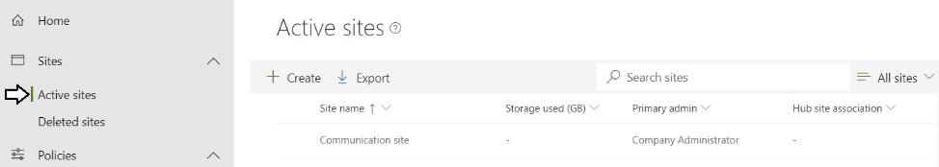
  - In the Active sites list, you should see the Communications site that was automatically created in your new tenant.
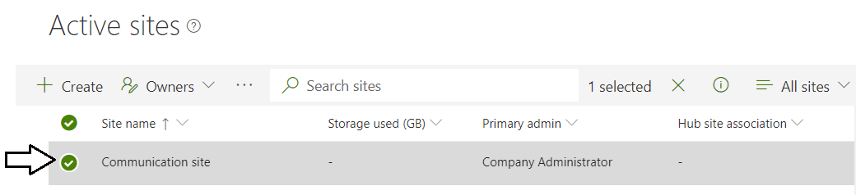
  - Click the Create button on the Active sites page to create a new site.
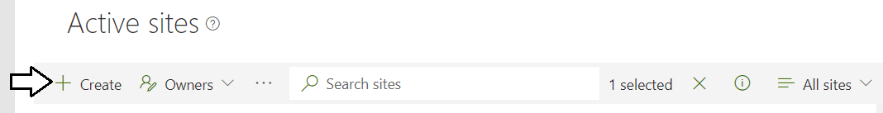
  - When prompted to Choose the type of site you'd like to create on the Create a site page, select Team site.
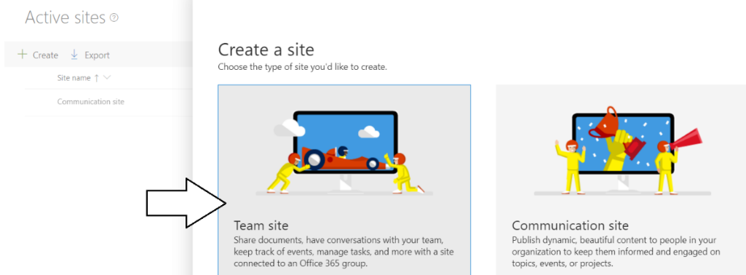
  - Add a Site name of Team Site.
  - In the Group owner section, add your new user account to make yourself an owner of the new site.
  - Click Next.
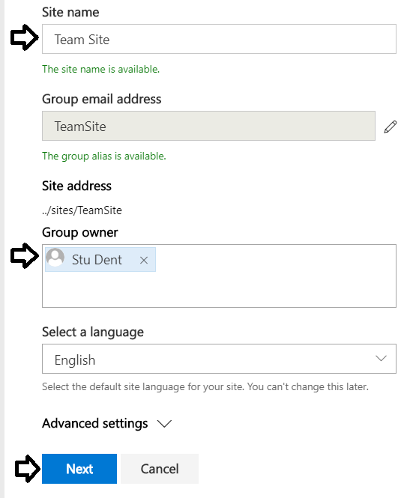
  - In the Add additional owners input control, the user Austin Powers.
  - In the Add members input control, and the users Jason Bourne and Jack Bauer.
  - Click Finish to create the new Team site.
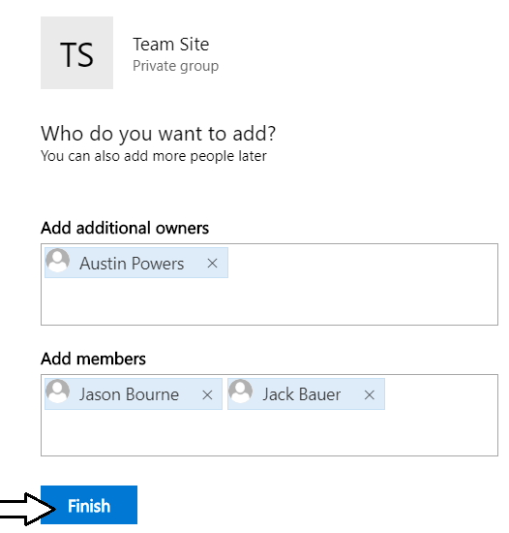
  - You should now be able to see your new site with a Site name of Team Site on the Active sites page.
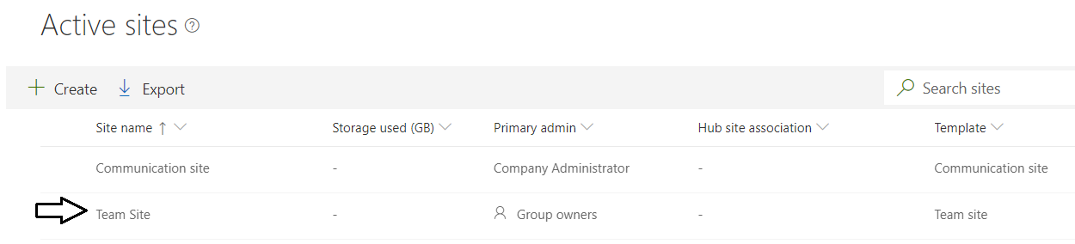
  - Click on the Team Site link in the Active sites list.
  - Locate and click on the URL in the property pane on the right to navigate to the new site.
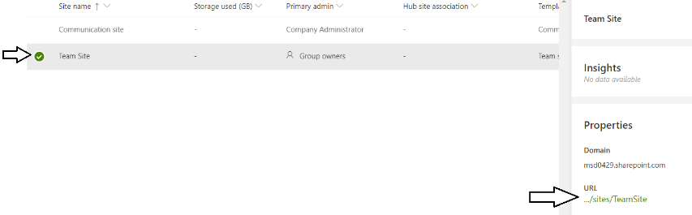
  - You should now see the home page of the new Team Site.
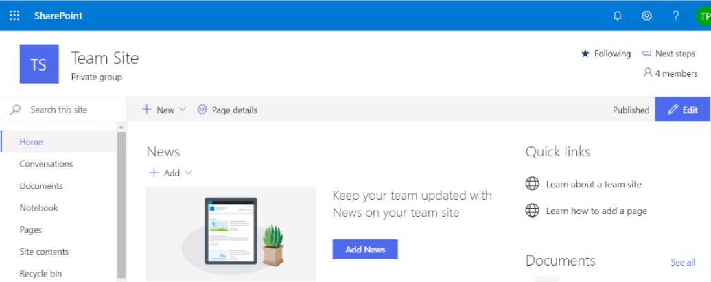
- Verify that a new Office 365 group has been created for the new Team Site.
  - Return to the Microsoft admin center at https://admin.microsoft.com/Adminportal.
  - Click on the Groups link in the left navigation.
  - You should be able to see that there is a new Office 365 group named Team Site.
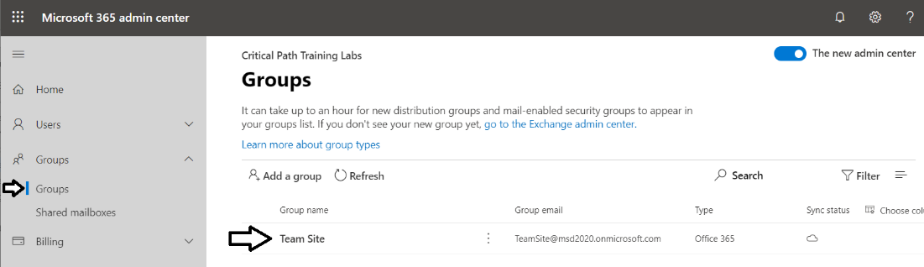
This Office 365 group was automatically created when you created the SharePoint Team site through the SharePoint admin center.

Exercise 6: Create a New SharePoint Site using PowerShell
In this exercise, you will use the SharePoint Online PowerShell module to connect to your Office 365 tenant. Note that this exercise assumes you have already installed the SharePoint Online Management Shell as discussed in the lab setup document.
- Connect to SharePoint Online and sign in using PowerShell.
  - From the Windows Start menu, open SharePoint Online Management Shell.
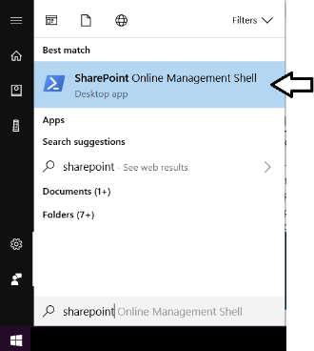
  - You should now see a new console window for the SharePoint Online Management Shell.
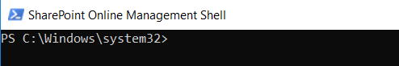
  - Run the following command to connect to your SharePoint Online tenant. Be sure to replace [your tenant] with the value you provided when creating your Office 365 tenant (this will be the same value that is preceding onmicrosoft.com in your login).
Connect-SPOService -Url https://[your tenant]-admin.sharepoint.com
When the Connect-SPOService cmdlet begins to execute, you will be prompted to sign in.
  - Enter the credentials of your primary Office 365 user account and click Sign In.
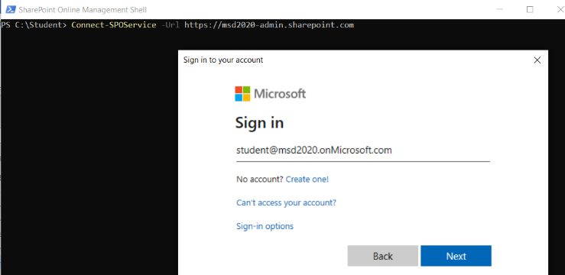
  - Once the call to Connect-SPOService returns, you can now begin to call the other SPO cmdlets.
- Execute SharePoint Online PowerShell cmdlets to view information about existing site collections in your Office 365 tenant.
  - Type and execute the following command.
Get-SPOSite
  - You should see that the call to Get-SPOSite displays the set of site collection in your Office 35 tenancy.
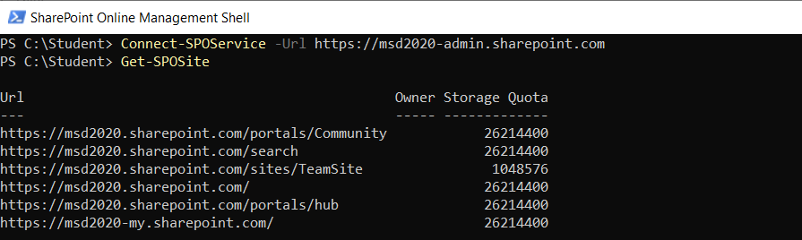
- Create a new Site Collection using the New-SPOSite cmdlet.
  - Execute the following lines of code to set up a few variables for the new site. Be sure to replace [Your tenant] and [Your User Account] with the value you provided when creating your Office 365 tenant
$url = "https:// [Your Tenant].sharepoint.com/sites/teamsite2"
$owner = "[Your User Account]@[Your Tenant].onMicrosoft.com"
$quota = 0
$siteTitle = "Team Site 2"
$template = "STS#3"
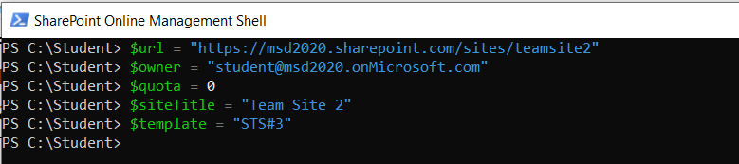
  - Execute the New-SPOSite cmdlet to create a new SharePoint site in SharePoint Online.
New-SPOSite -Url $url -Owner $owner -Title $siteTitle -StorageQuota $quota -Template $template
  - The New-SPOSite cmdlet will block while the site is being created.
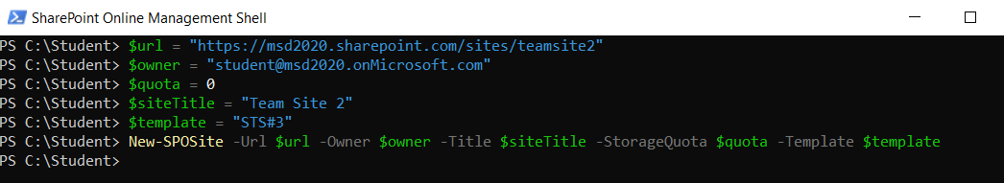
  - If you move back to the SharePoint admin center, you should be able to see the new Team site has been created.
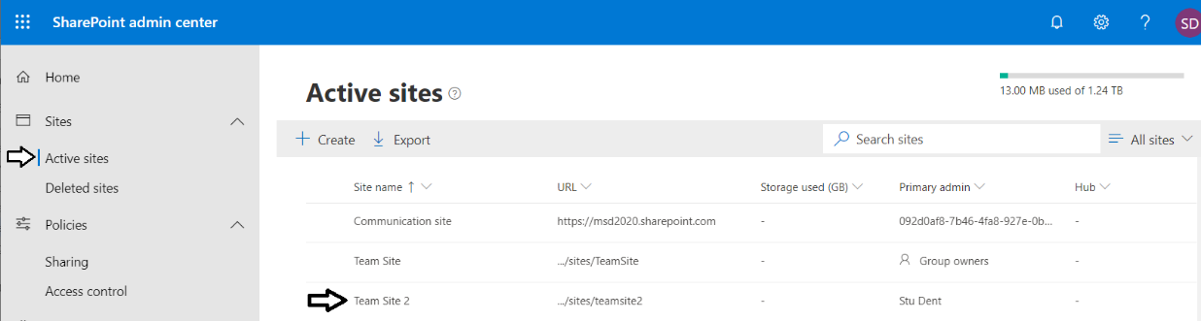
Note that the New-SPOSite cmdlet provides a -NoWait parameter for scenarios where you want your PowerShell code to continue running while the site is being provisioned.
  - Return to the SharePoint Online Management Shell and wait until the call to New-SPOSite completes.
  - Execute another call to Get-SPOSite and make sure you see the new site collection you just created.
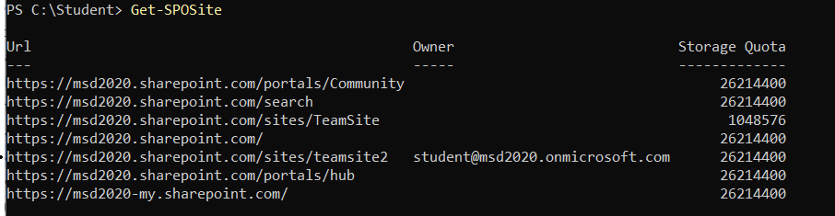
  - Execute the following PowerShell command to get more information about the new site.
Get-SPOSite -Identity $url | select *
  - You should see a list of properties similar to what you can see in the following screenshot.
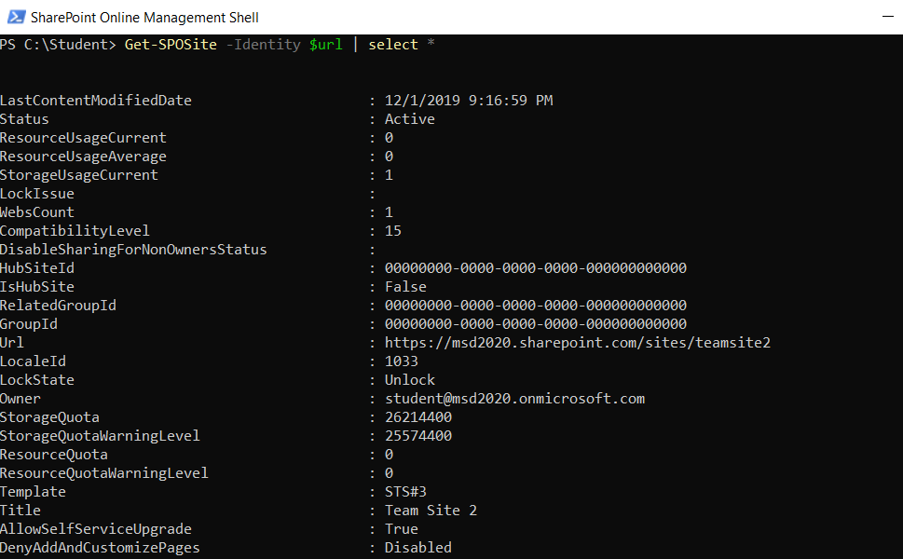
  - Execute the following PowerShell command to write back to SharePoint by modifying the title for a SharePoint site.
Set-SPOSite -Identity $url -Title "A New and Better Title"
  - Run the following PowerShell command to open the new SharePoint site in the browser.
Start-Process $url
  - Take a moment to inspect your new SharePoint Online site.
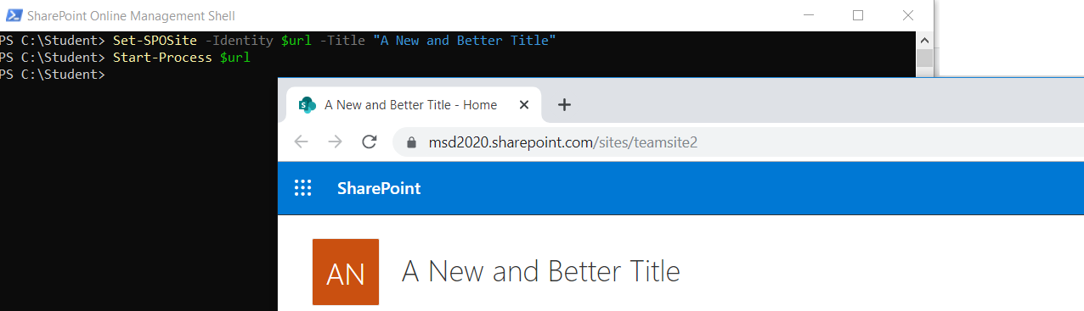

Exercise 7: Creating SharePoint Lists with the Client-side Object Model (CSOM)
In the following exercise, you will open and run a Visual Studio solution with a C# console application that uses CSOM to create site columns, a content type, a picture library and a list of data for a set of products. You will configure the C# console application to add these SharePoint site elements to the new site collection you created in the previous lab exercise.
- Open the Visual Studio project named AddWingtipProductsList.sln.
  - In Windows Explorer, navigate to the following folder.
C:\Student\Modules\01_GettingStarted\Lab\AddWingtipProductsList
  - In this folder you should see a Visual Studio solution file named AddWingtipProductsList.sln.
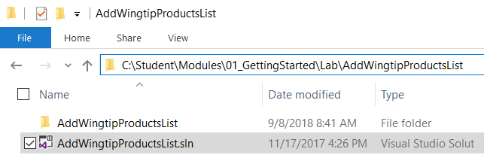
  - Double click on AddWingtipProductsList.sln to open the solution in Visual Studio 2017.
  - When the solution opens in Visual Studio, click the App.config file to open it in an editor window
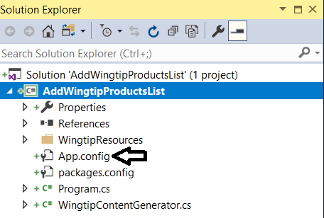
  - The App.config file contains three appSetting values named targetSiteUrl, username and password.
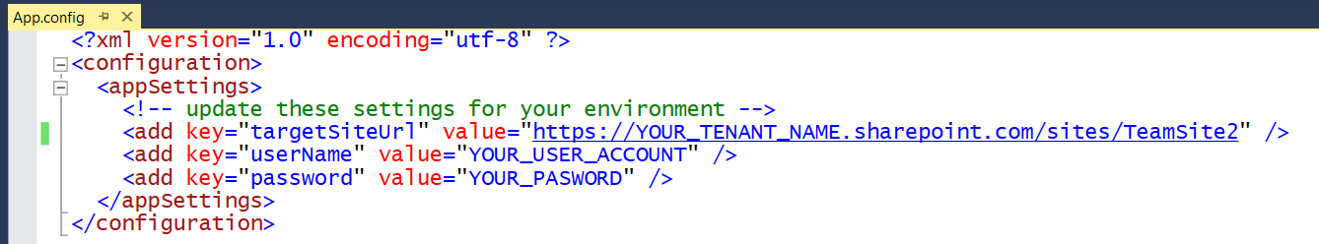
  - Update the AppSetting values with the site URL you created in earlier and with your Office 365 user account details.
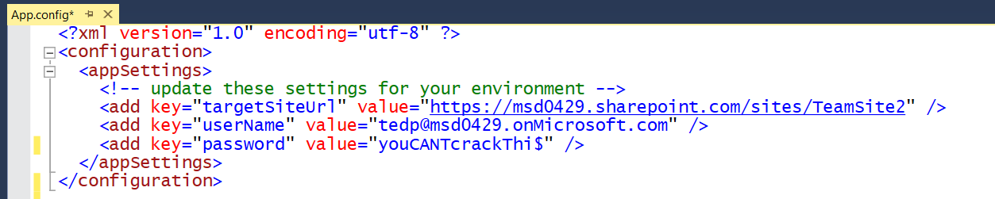
  - Save your changes to App.config.
At this point, you are ready to run the application and execute the CSOM code against the new site you created earlier.
  - Press the {F5} key in Visual Studio 2017 to run the AddWingtipProductsList program.
  - You will see output in the console window as the program runs.
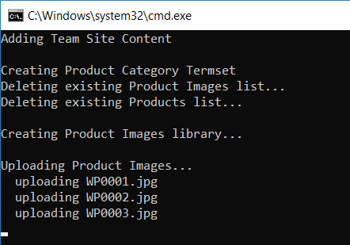
  - Wait until the program completes and then navigate to the SharePoint site to the changes.
  - You should see that there are two new links in the left navigation for Product Images and Products.
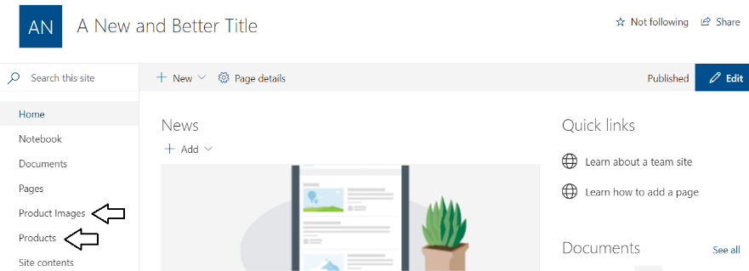
  - Click on the Product Images link to see the Picture Library that was created and the images uploaded by the CSOM code.
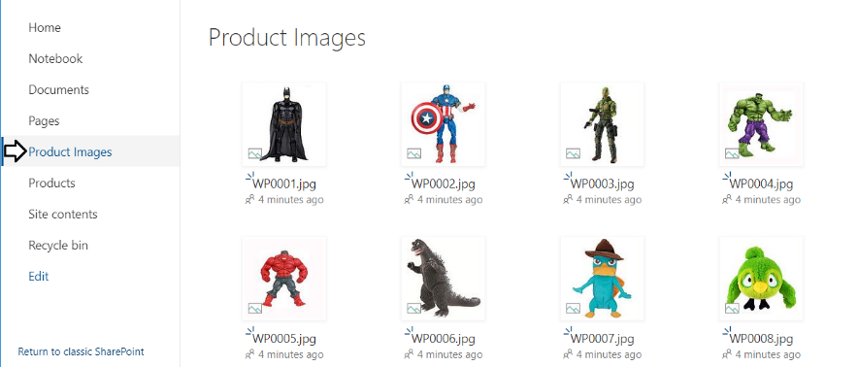
  - Click on the Products link to see the custom list and product items that were created by the CSOM code.
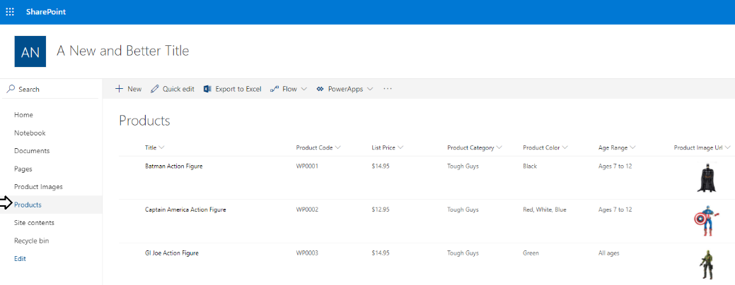
  - Return to the AddWingtipProductsList solution in Visual Studio 2017.
  - Open the file named WingtipContentGenerator.cs.
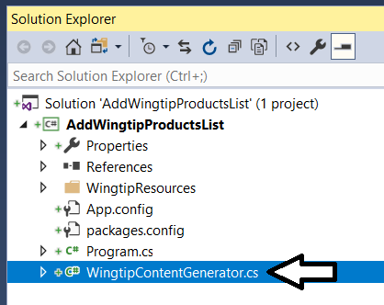
  - Take a few minutes to examine the CSOM code that was used conduct the provision of SharePoint site items.
  - When you are done, close Visual Studio.

Exercise 8: Getting Started with an Azure Subscription
In this exercise you will create a trial Azure subscription using the primary account that was created in your Office 365 tenant.
IMPORTANT: Over the steps of this lab exercise, it is critical that you authenticate using the primary Office 365 user account that was created for you when you created the Office 365 tenancy earlier in this lab. Make sure you do not log into any site on the Internet using any personal account or organization account other than your primary Office 365 user account. If you have logged on to any site using another account, then you should close all browser instances and then launch a new browser session for this exercise.
If you have an Azure subscription, skip ahead to Exercise 9: Connect to Your Microsoft Azure Subscription using PowerShell.
- Sign up for a free Microsoft Azure trial account using your primary Office 365 account.
  - Navigate to https://azure.microsoft.com/en-us/free/.
  - Click the Start Free button to go to the sign up screen to navigate to the Free trial sign up page.
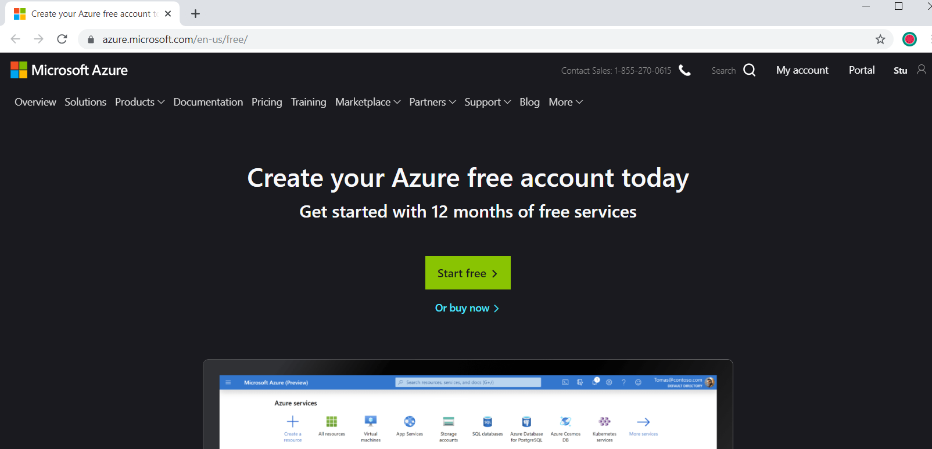
  - Once you get to the Free trial sign up page, start by looking at the logged in user name in the top right corner of the page and verify that you are logged in under the identity of your primary Office 365 user account. Also verify that the Country/Region setting is correct. Fill in the rest of the information requested in the About you section and then click Next.
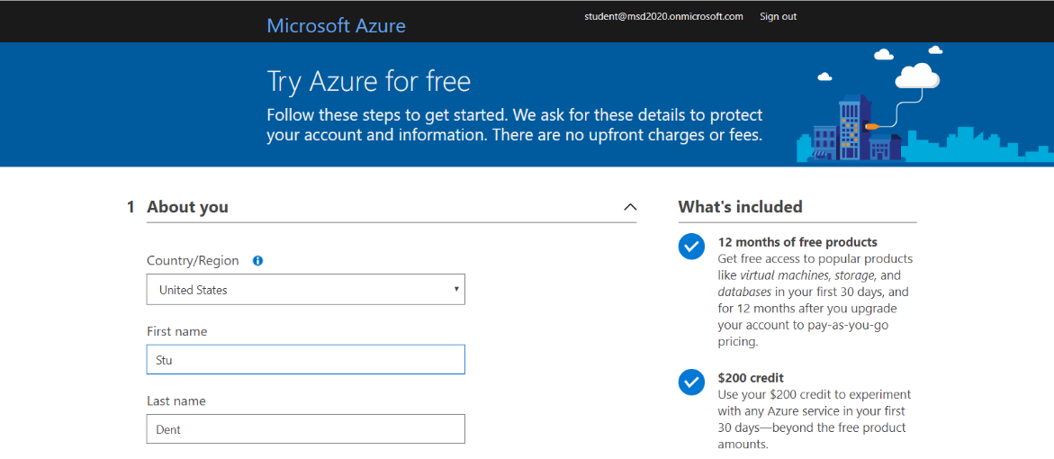
  - In the Identity verification by phone setting, enter the phone number of your mobile phone and click the Send text message button. Wait until you receive a text message with your access code.
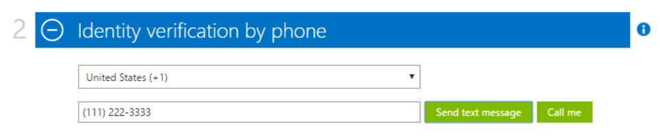
  - Once you receive the text message with the access code, enter the access code in the bottom textbox and click the Verify code button.
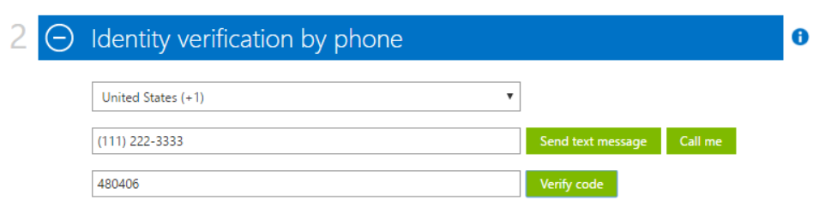
  - In the Identity verification by card section, you must enter the information for a valid credit card. This is a required step. Once you have entered the credit card information, click the Next button to verify the credit card information.
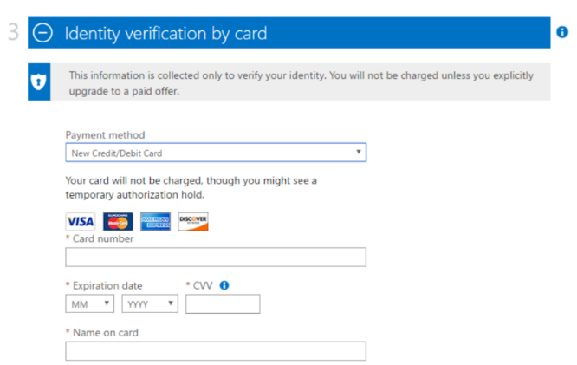
Note that Microsoft will not charge your credit card for any type of Azure usage as you work with new your free trial subscription. However, your credit card information is retained by Microsoft in case you upgrade your free trial to a pay-as-you-go subscription.
  - Complete the final step in the Agreement section by checking the I agree checkbox and clicking the Sign up button.
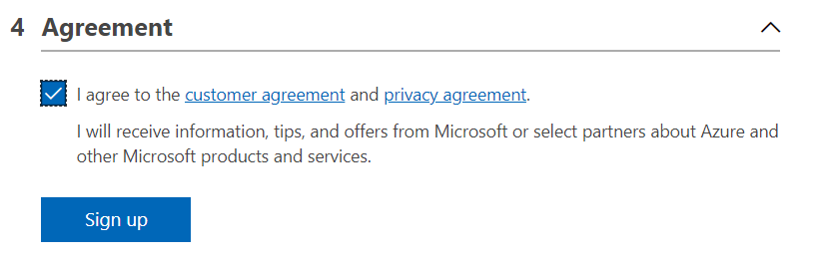
  - You should now see a page that indicates your free trial Azure subscription has been created.
  - Once the setup process completes, click on the big button on the page to navigate to the new Azure portal.
  - You should now see the main page of the Azure portal which displays the dashboard and the left navigation menu.
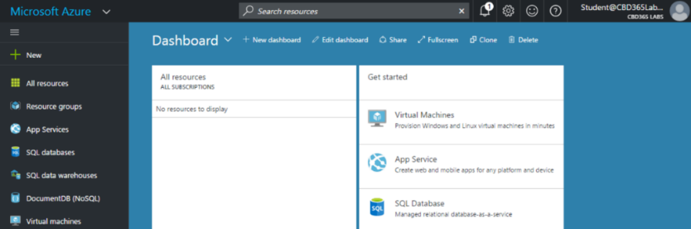
  - Locate and click the Billing link which is down toward the bottom of the left navigation menu.
  - When you click Billings, the Azure portal will display a pane which shows your subscriptions at the bottom. Note that this view allows you to see and copy the GUID associated with your subscription. Note that you should copy this GUID and save it to a local text file because you will need it in later lab exercises.
Now that you have an active Azure subscription, it's time to test out this subscription by using a few Azure PowerShell commands.

Exercise 9: Connect to Your Microsoft Azure Subscription using PowerShell
In this exercise, you will use the Azure ARM PowerShell module to verify PowerShell connectivity to your Azure subscription. Note that this exercise assumes you have already installed the Azure PowerShell modules as discussed in the lab setup document.
- Open up a PowerShell command prompt.
- Use PowerShell to establish a login to Microsoft Azure
  - Type and execute the following PowerShell command to establish a login to Microsoft Azure.
Login-AzureRmAccount
  - The first time you execute the Login-AzureRmAccount cmdlet, you might be prompted as to whether you want to allow Azure PowerShell to collect data. If you see this prompt, you can answer with either a Y or an N.
  - When the Login-AzureRmAccount cmdlet begins to execute, you will be prompted to sign in. Enter the credentials for the user account associated with your Azure subscription and click Sign In.
  - When the Login-AzureRmAccount cmdlet executes successfully, it displays the information shown in the following screenshot. You should be able to see the GUIDs for your Azure subscription and for its associated Azure AD tenant.
Make sure you see a SubscriptionId value for your Azure subscription. If you have more than one Azure subscription, you might need to make one of them the active subscription by calling the Set-AzureRmContext with the SubscriptionName parameter.
  - Type and execute the Get-AzureRmADUser cmdlet to display the users in your Office 365 tenancy.
Get-AzureRmADUser
  - When Get-AzureRmADUser executes, it should display information about the user accounts the Azure AD tenant associated with your Azure subscription.
You have now completed all the exercise in this lab.

